**What To Bring For Each Child.**

|  |  |
| --- | --- |
| **Every Day:**   * School backpack clipart free clipart images - ClipartixNappies * Wipes * Meals * Spare clothes – Top, bottoms, socks, pants, vests if worn. * Drink bottle (we do have spares) * Milk bottles – and formula if they still drink baby’s milk * Bookbags | Sunshine sun clip art clipartandscrap jpg - Clipartix**Additional In Warm Months**:   * Sun Cream * Sun Hat * Suitable spare clothes (light jacket or coat for British weather. |
| Free Snowflake Png Transparent, Download Free Snowflake Png Transparent png  images, Free ClipArts on Clipart Library**Additional In Cold Months:**   * Warm Hat * Gloves * Scarf * Suitable spare clothes |

Please ensure all items are **clearly labelled** with your child’s name. This includes lunchboxes, clothes, water bottles, tubs etc. We can absolutely label items for you using marker pens. This is to ensure items are not lost or mixed up.

We do not have enough storage to hold children’s items in the setting e.g large bags of nappies.

Bookbags are also required everyday for updates on your child’s development, photos, notes on their how their day has gone and crafts they have made for you.

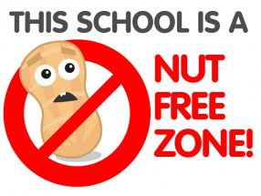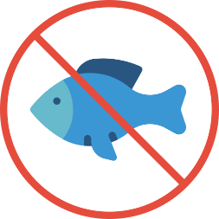

**Due to allergies and intolerances, please do not provide any food items containing**

**nuts (including Nutella) and fish.   
We ask that anything including allergens is tried at home before being provided for your child in our setting.**

|  |  |  |  |
| --- | --- | --- | --- |
| Food Allergens awarness or management training courses | **Sulphur  Dioxide** | **Food Allergens awarness or management training courses** | **Nuts** |
| Food Allergens awarness or management training courses | **Lupin** | **Food Allergens awarness or management training courses** | **Fish** |
| Food Allergens awarness or management training courses | **Mustard** | **Food Allergens awarness or management training courses** | **Eggs** |
| Food Allergens awarness or management training courses | **Celery** | **Food Allergens awarness or management training courses** | **Milk** |
| Food Allergens awarness or management training courses | **Sesame** | **Food Allergens awarness or management training courses** | **Molluscs (Shellfish)** |
| Food Allergens awarness or management training courses | **Soya** | **Food Allergens awarness or management training courses** | **Crustaceans (Shellfish)** |
| Food Allergens awarness or management training courses | **Cereals  Containing  Gluten** | **Food Allergens awarness or management training courses** | **Peanuts**  **Due to this not being well known information, please be aware that children should not have honey**  **before they reach the age of 1. All the allergens above should be tried at home before being provided in lunchboxes.**  **We ask for no Fish, Nuts or Peanut items in lunchboxes due to allergies and  intolerances.** |

**ALLERGENS**