Contract - Childminder/Parents
Private and confidential
This contract and any supporting documentation constitute a legally binding agreement for childminding services.
This contract is to be completed with a child record form and parental consent forms; please complete one set of forms for each child.
Details of Childminder
Name |  | Telephone Number
Little Ladybirds Childminding. |  | Louisa - 07565 038 261
 |  | Hannah - 07745 157657
Address |  | Ofsted Registration Number
24 Blake Road  Bicester  OXON  OX26 3HJ |  | EY 2659814
 |  | Email Address
 |  | louisahannah2021@outlook.com
 |  | Public Liability Insurance Company
 |  | Morton Michel

Details of Child:
Child’s Name |  | Date of Birth
Details of Parent or Carer 1
Name |  | Home Telephone Number
Address |  | Work Telephone Number
 |  | Mobile Telephone Number
Details of Parent or Carer 2
Name |  | Home Telephone Number
Address |  | Work Telephone Number
 |  | Mobile Telephone Number

Settling In Period
A settling in period of 14 sessions will start from your child’s first day with us at Little Ladybirds. During this time, the notice period does not apply; both parent/ guardian and childminder withhold the right to terminate the contract, at any point within this time, with no prejudice and immediate effect.
Every Day:  - Nappies  - Wipes  - Meals  - Spare set of clothes – Top, bottoms, socks, vests if worn.  - Drink bottle (we do have spares)  - Milk bottles – and formula if they still drink baby’s milk  - Bookbags | Additional In Warm Months:  - Sun Cream  - Sun Hat  - Suitable spare clothes (light jacket or coat for British weather.
Additional In Cold Months:
- Warm Hat
- Gloves
- Scarf
- Suitable spare clothes
The following will be provided by parents, daily:
Please ensure all items are clearly labelled with your child’s name. This includes lunchboxes, clothes, water bottles, tubs etc. We may need to label them for you.
Bookbags are also required everyday for updates on your child’s development, photos, notes on their how their day has gone and crafts they have made for you.

Contracted Hours and Days
Day | Drop-Off  Time | Pick-up  Time | Rate per  hour (£) | Total:
Monday
Tuesday
Wednesday
Thursday
Friday
☐ 15 Hours Funded.  ☐ 30 Hours Funded.  ☐ My Child Does Not Yet Receive Funded Hours.  If your child receives funding, please tick the correct box below. |  |  | Total Weekly  (approx.) :
 |  |  | Total Monthly (approx.) :

Any other arrangements:
Additional Charge | £ payable
Bank holidays | Full Fee  Please note, we do not work bank holidays.
Late Collection / Early Arrival fee | £10
Outing Fees | Via special arrangement
Late Payment Fee | Any payments to reach our account after the 28th of the month will generate a £40 fee to be issued to the next invoice.
Fees for Absences
Childminder sick/ occasional days off | No Fee
Childminder holiday  Holiday is defined as a period of time of 3 consecutive days or more – Not including Weekends or bank holiday. | Half Fee
Parent sick/ child sick; occasional  days off | Full Fee – subject to change due to circumstance at the childminder’s discretion
Parents annual holidays/ Retainers  for teachers and others with  extended holidays  Holiday is defined as a period of time of 3 consecutive days or more – Not including Weekends or bank holiday. | Half Fee

Holidays
- ‘Holiday’ is defined as a period of time of 3 consecutive days or more – Not including Weekends or bank holidays.
A minimum of 4 weeks’ notice to be given by childminder and parents of forthcoming holidays. Bank holidays are included in childminders holiday.
Number of days holiday childminder expects to take in a year | 28 - 30 |  | Numbers of days holiday parents expect to take in a year

Per Hourly Fees.
Fees are due a month in advance by the 28th of every month.
Children Attending Full Time Education. |  | Children Full Day Fee.
£5.90 per hour. |  | £4.90 per hour.
Late fees apply - £10 per hour outside of scheduled hours.

Deposit
This will hold the place open for a maximum of 4 weeks unless discussed otherwise. Retainers should only be charged to secure a current childminding vacancy.
Amount To Be Paid |  | To cover period from:
£100
This deposit is not refundable unless the childminder no longer has a place available.
The deposit will be deducted from your first monthly invoice, once your child starts with us.

Payment Details
Name of person responsible for payment
Payment method
Payment in advance
Date Payment due | Payments are due by the 28th of each month. (This means payments are to have cleared by this date).

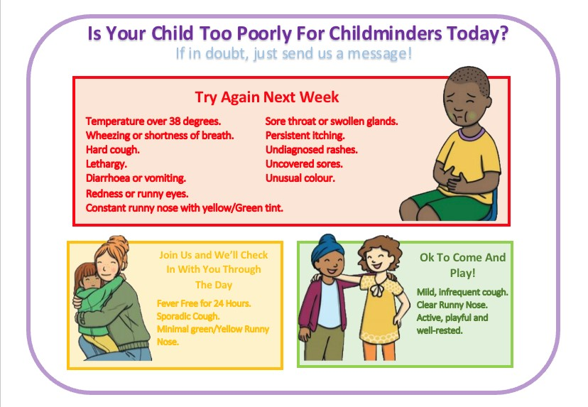
Sickness Policy
It is key to us that all policies and procedures are read and understood before your child starts with us at our setting. This includes the illness policy.
We wish for all parents to contact us if unsure on whether the child may enter the setting with any signs or symptoms of illness they show. Within your welcome pack, you will receive a simple and easy-to-follow guide on our sickness policy to keep at home.
If your child is showing any symptoms in our red list and/or is given any mediation at home, to get them through the day, we ask that you do not bring them into the setting as we have a duty of care to stop any infection or illness spreading.
We understand this can be inconvenient but we appreciate your cooperation.
Meals
At little ladybirds we promote healthy eating both within and outside of our setting. Although we do not provide food we are more than happy to reheat food, that has previously been cooked at home, using the microwave.
Unfortunately, we are unable to use the oven to cook individual meals for the children.
Notice period of changes to contract
2 week’s notice to be given by childminder.
Termination of Contract
To end the childminding agreement 4 week’s notice in writing to be given by parents or childminder, otherwise payment or refund of remaining fees are due.
Parents or childminder have the right to terminate the contract immediately and without prejudice in the following circumstances: (Either party reserves the right to request legal advice in the case of contract termination).

- Non-compliance with policies and procedures
- Non-payment of fees
- Child behaviour that does not improve after consistent support from parents and childminder
- Behaviour which is not conducive to a safe working environment
- Non-compliance with the contract
- We will not tolerate any innaporpriate or intimidating behaviour towards staff members, children or member of household, as this will result in immediate contract termination with no notice period.
Any fees owed to the parent/guardian remaining, will be refunded.

I/We have read and agree to the terms and conditions set out in this agreement
Childminder Signature
- I agree to provide suitable activities & outings to promote your child’s learning and development.
- I will give regular feedback on your child and their progress.
- I will comply with Ofsted registration requirements and have up to date Public Liability Insurance.
- I will ensure that all documentation is completed and stored securely.
- I will ensure that you are given copies of any contract arranged on request.
Childminder’s Signature |  | Date

Parent/s Signature
- I agree to pay fees as set out in this contract on time and arrive promptly to deliver and collect my child.
- I agree to comply to all policies and procedures, including the sickness policy and will contact the setting before the session, if unsure on whether my child should attend when showing signs of illness.
- I will inform my childminder of any illness or accidents that occur out of the childminding setting.
- I will provide any information required by my childminder in connection with registration and be available to receive the feedback from my childminder regarding my child’s day.
- I will work closely with the childminder to promote the best possible well-being and outcomes for my child.
Parent signature: |  | Date:
Additional Parent signature if applicable: |  | Date:

